New Mexico Letters About Literature
Read. Be Inspired. Write Back.
OFFICIAL RULES
1. New Mexico Letters About Literature writing competition is open to students with a legal residence in the state of New Mexico.
2. Students must be in grades 4 through 12 during the 2021-22 school year.
3. The program year starts September 1, 2021, and concludes June 1, 2022.
4. Entries will be accepted starting November 1, 2021. Limit one (1) entry per student.
5. There will be three (3) Levels of Competition:
a. Level 1 for Grades 4 – 6
b. Level 2 for Grades 7 – 8
c. Level 3 for Grades 9 – 12
6. Students select a fiction or nonfiction book, short story, poem, essay, or speech (excluding song lyrics) that they have read and about which they have strong feelings. Note to teachers: Please do not assign a particular work to students; rather, allow students to choose a work of literature that speaks to them personally.
7. Students write a personal letter to the author of their selected piece of literature explaining how the work changed the student’s view of themselves or their world. The letter’s aim is not to flatter the author, summarize the piece of literature, or serve as a book report; rather, the letter creates a conversation with the author in which the student expresses thoughts, feelings, and/or ideas inspired by the author’s writing, as well as its impact on the student’s life. Students should write honestly and from their own perspectives.
8. Entries must use no fewer than 300 words for 4th grade and no fewer than 400 words for 5th through 12th grades. No entry may be more than 800 words for all grades.
9. Entries must include the date, a greeting, body of the letter, a closing, and the student’s first name ONLY in the signature. Note: These elements will be included in the entry’s word count. However, entries must NOT include a last name in the signature, school name, city, or return address on the letter.
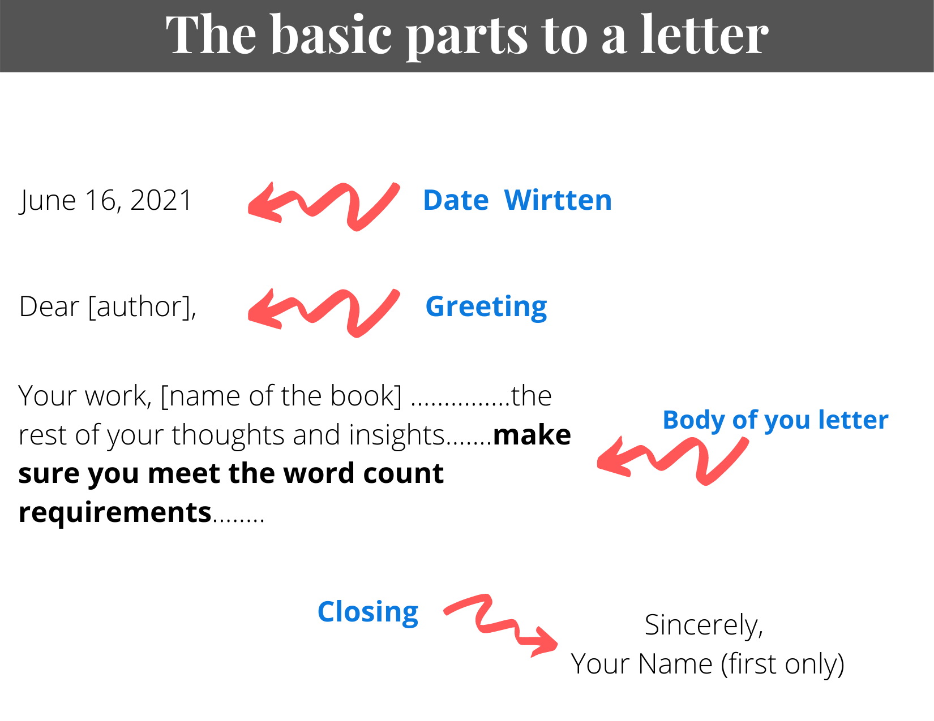
10. Entries must be submitted via electronic submission or via mail by the due date. An entry form with all required information must be completed and submitted with the student’s letter. The entry form must be submitted with class or individual entries.
11. Students under the age of 13 (as of 11/1/21) must submit a permission form with the signature of a parent/legal guardian to be eligible for entry. Entries by/for students under the age of 13 without a signed form will be ineligible and discarded.
12. Plagiarized letters or letters that are not the original and sole work of the student will be disqualified.
TERMS OF PARTICIPATION
1. ENTRIES: Each entry must be the original creation of the submitting student; must be previously unpublished and cannot have been submitted to any other competition; must not infringe upon or violate the rights of any third party; and must be truthful in its content. By submitting an entry each student (and/or parent/legal guardian if the student is under the age of 13) should review and completely understand the Terms of Participation and Official Rules for entry. No other form of participation other than as stated in these Official Rules is valid. Entries will be viewed by the New Mexico Letters About Literature Program staff, for administration purposes, and by the judges for the competition. Otherwise, entries will remain confidential, unless the State Library is compelled under penalty of law including the New Mexico Inspection of Public Records Act to disclose.
2. PERMISSION TO PUBLISH WINNERS: If a letter is selected as a winner, the student’s parent/legal guardian will be contacted for permission to publish the student’s letter and a signed release allowing publication of the student’s letter will be required in order to publish and collect the prize. If permission is declined for state winners, an alternate winner will be determined. All letters submitted become the property of the State Library. No letters will be returned. Therefore, the State Library suggests that students keep a copy of their entry.
3. JUDGING: Entries will be judged at the state level by a panel of judges selected by the State Library for each level of competition. Entries will be judged against entries within the same level of competition by representatives from the state library or chosen by the state library. Entries will be judged in three rounds. The identity of the judges will be public information. The decisions made by the judges are final and binding.
4. SELECTION OF WINNERS: One (1) entry in each level of competition (three total) with the highest cumulative point score will be declared the New Mexico state winners. After the state winners are determined, the next entries with the highest cumulative point scores for each level of competition will be declared the state second place winners and the third place winners (six total). After the second and third place winners are determined, the judges may award honorable mentions for each level of competition. In case of a tie, entries will be evaluated by a new judge according to the original criteria and the tied entry with the highest cumulative score by the new judge will be declared a first, second, or third place winner. The state winners and honorable mention writers will be notified in late spring 2022.
5. PRIZES: Prizes to be determined. If the winners cannot accept their prize as stated, the prize will be forfeited in its entirety. If the winner is a minor, prizes may be awarded in the name of, or to, the winner’s parent/legal guardian who must execute all documents and agree to all obligations and undertakings of the winner, both on behalf of himself/herself and the winner in order to collect prizes. An awards ceremony will take place in Santa Fe in late spring 2022 where the winners will read their letters aloud and receive their prizes. Due to COVID-19, ceremonies may be subject to change and will be dependent on existing orders for gatherings in force at that time under the directive of the Governor of New Mexico.
6. WINNERS’ LIST: For names of the winners, visit - https://lettersaboutliterature.nmculture.org/ . Winners will be posted in late spring 2022.
7. SPONSOR: New Mexico State Library, Department of Cultural Affairs, 1209 Camino Carlos Rey, Santa Fe, New Mexico 87507. The New Mexico Letters About Literature state writing contest is made possible by: the New Mexico Center for the Book with additional support from the New Mexico State Library Foundation.

