New Mexico Letters About Literature
Read. Be Inspired. Write Back.

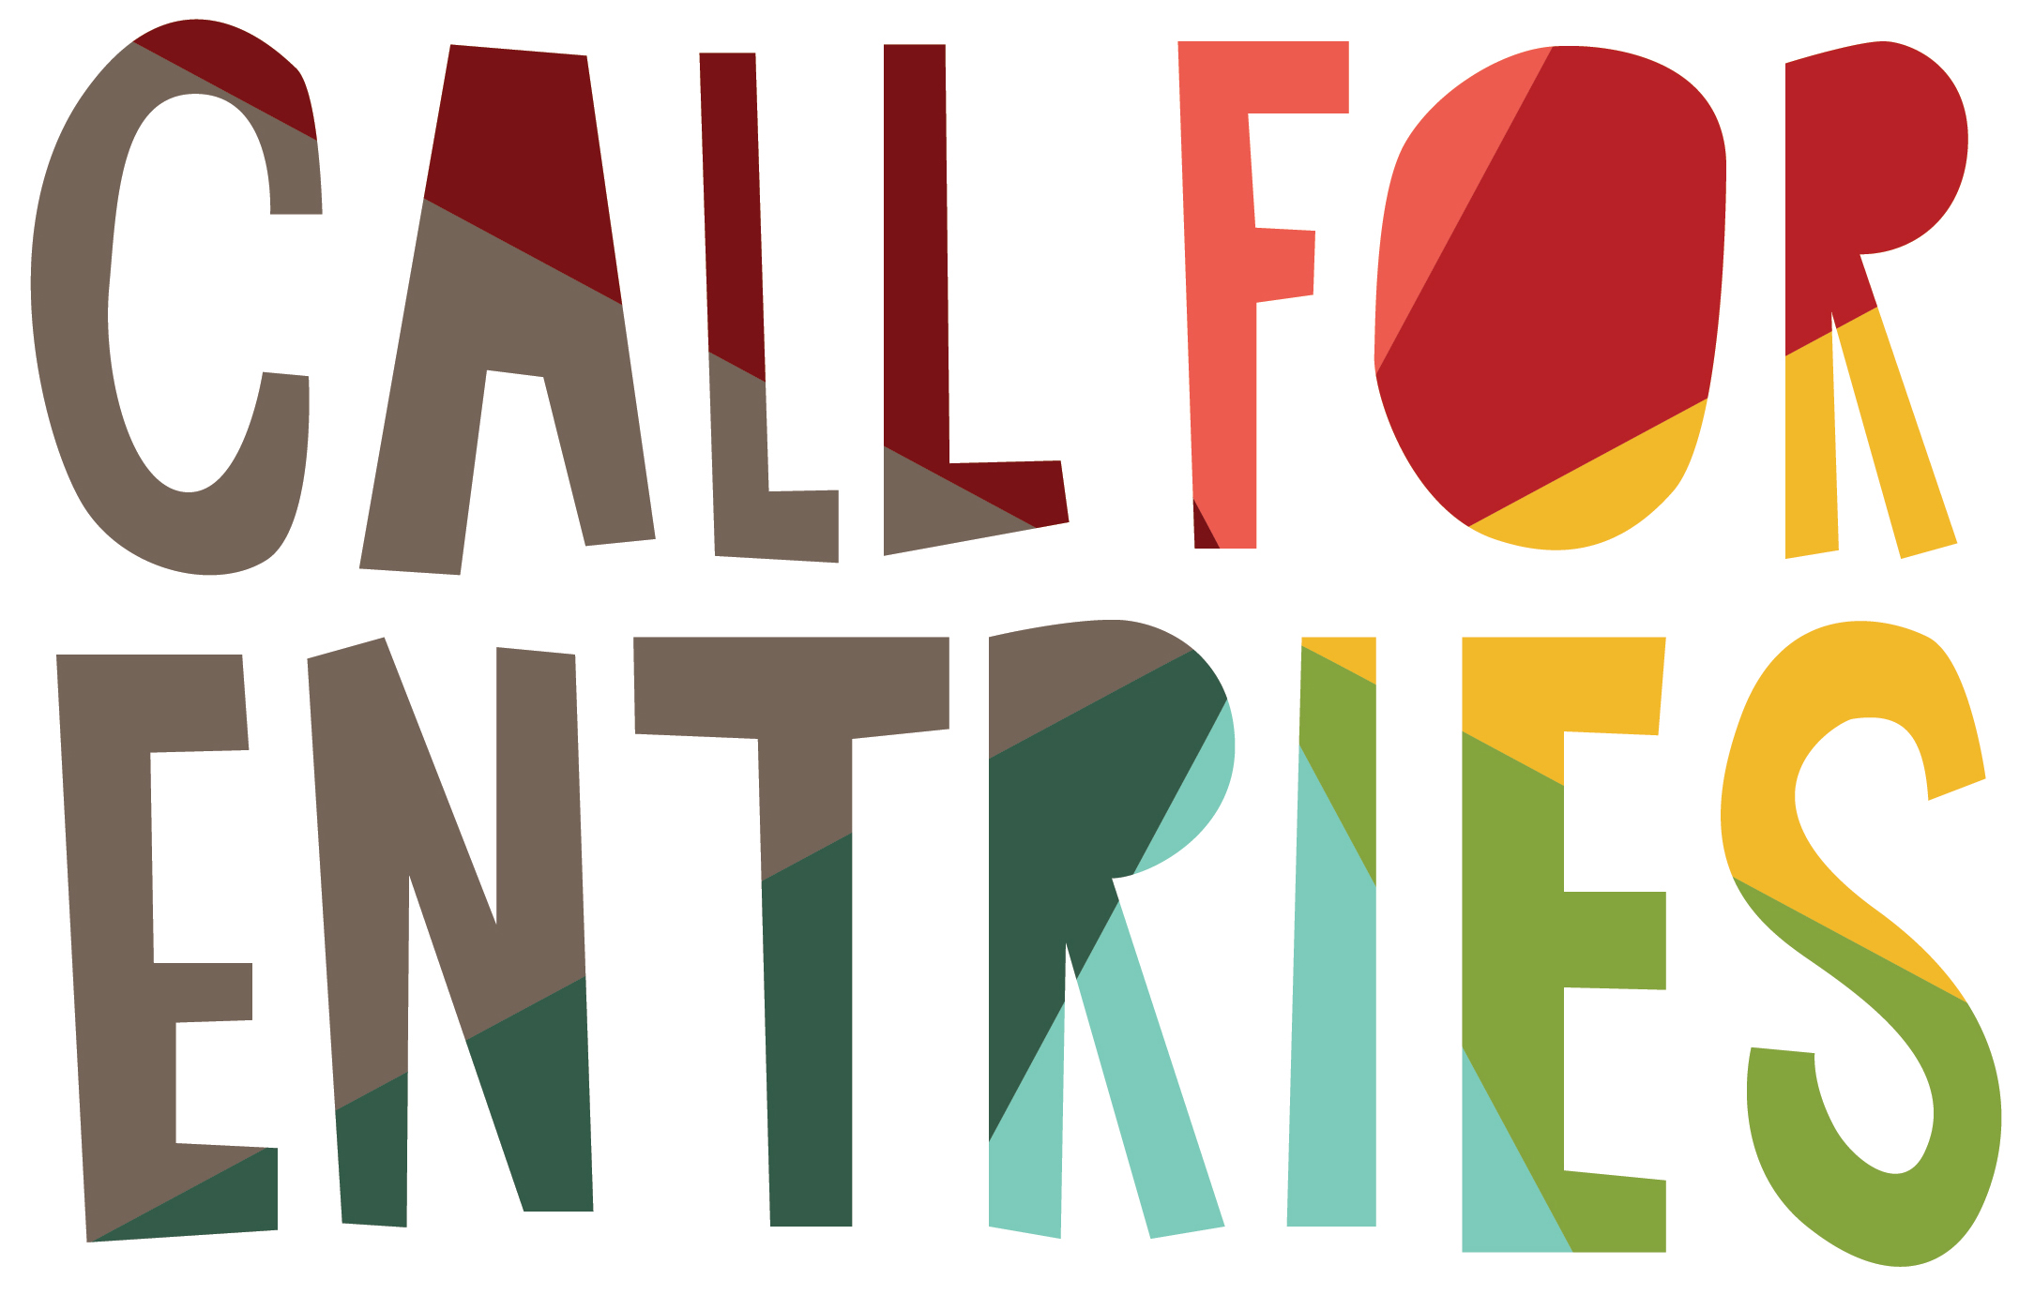

The New Mexico State Library invites students in grades 4 through 12 to enter the New Mexico annual
LETTERS ABOUT LITERATURE WRITING COMPETITION!

Polish up your reflective writing skills and write a letter to an author—living or dead—explaining how his or her work changed your view of yourself or your world.

THREE COMPETITION LEVELS:
Level 1: Grades 4, 5 and 6
Level 2: Grades 7 and 8
Level 3: Grades 9, 10, 11 and 12

Entry Deadline (all competition levels): December 30, 2022

HOW TO ENTER:
Review the official contest rules for entry details, specifically #6 through #9.
1. Select a book that you have read and about which you have strong feelings or which has changed your view of yourself or the world.
2. Imagine sitting down with the author of this work and sharing your personal thoughts. Your letter should be reflective, personal and sincere, like a private conversation, not a book report or a fan letter.
3. Share specific details about the book and about your reaction to the book.
4. Keep in mind that this is a reflective writing contest and that means you need to think about what you read and the meaning you gleaned from the author’s words as well as the impact of those words upon you.
5. Type your letter. Use your first name ONLY in the signature.
6. Complete the entry form (see the next page) and staple it to the top of the first page of your letter.
7. Complete the permission form (see https://lettersaboutliterature.nmculture.org/) for all entries age 13 or under as of November 1, 2022.
8. Enclose your letter and the required form(s) in a letter-sized envelope. TEACHERS’ NOTE: Please mail class sets in one large flat envelope 9” x 11” (or larger).
9. Indicate the competition level on the envelope—Level 1, or Level 2 or Level 3—depending on your grade. If you are submitting for more than one level, use a separate envelope for each level.
10. Mail your entry to:
New Mexico Letters About Literature
New Mexico State Library
1209 Camino Carlos Rey
Santa Fe, NM 87507
11. Alternatively you may submit your entry electronically at NM.LAL@state.nm.us
- Microsoft Word or PDF documents only will be accepted electronically.
- Entry form and signed permission form for all entries age 13 or under as of November 1, 2022 are required for all electronic submissions and both must be sent as separate attachments.

AWARDS:
Winners in all three competition levels will be recognized at an awards ceremony and prizes will be awarded. The State Library will announce all finalists and winners and will publish the three winning letters on its website in April 2023. The awards ceremony will be held in Santa Fe in early May 2023. Due to COVID–19 please be advised that scheduling and venue for the awards ceremony are subject to change.

ASSESSMENT - All entries will be judged on the following criteria:
Round 1: Audience: Is the entry in letter format and does it address the author of the work? Entries that are not in letter format and are written about the author or work rather than to the author will be eliminated. Purpose: Does the entry address the theme of the contest of how an author’s work changed the reader’s view of self or the world? Is personal reflection evident in the letter? Entries that are below the required word count, book summaries or letters that are predominantly fan letters to the author will be eliminated. Letters that meet these criteria advance to Round 2.
Round 2: Grammar: Is the entry written in a clear and organized way with specific details to support the main ideas? Single-paragraph letters and those with significant grammatical errors will be eliminated. Originality: Does the entry express ideas creatively? Does the entry communicate a unique voice or powerful point of view? Letters that are formulaic without evidence of a writer’s voice will be eliminated. Letters that meet these criteria advance to Round 3.
Round 3: A panel of judges selected by the State Library for each competition level will choose the top letters in each competition level. State finalists will be scored by the following criteria: addressing the theme of the contest, letter content/details, creative expression, originality, and letter structure and grammar.

HOW TO SUBMIT LETTERS:
Entry Form: Each letter must be accompanied by an entry form (below). The State Library will contact winners using this information, so be sure entry forms are complete and legible! Letters without an entry form will be eliminated. If you are mailing your entry, staple the form to the top of the first page of the letter.
Class Set of Letters: Teachers must submit their name and contact information with a list of the names of each student submitting a letter. This list does not take the place of entry forms. Each student’s letter must have its own entry form. For students under the age of 13, a signed permission to participate form is also required with the entry. Mail class sets in a large, flat envelope 9” x 11” or larger.
Electronic Entry: Letters must be Microsoft Word or PDF documents and must be accompanied by an entry form attachment. Letter writers age 13 or under as of November 1, 2022 must also submit a signed permission to participate form which is available on the State Library website https://lettersaboutliterature.nmculture.org/, also sent as a separate attachment.
Ownership: All letters become the property of the State Library. Please keep a copy of your entry(ies), as no letters will be returned.
Postal Mailing Address: Electronic Mailing Address:
New Mexico Letters About Literature NM.LAL@state.nm.us
New Mexico State Library
1209 Camino Carlos Rey
Santa Fe, NM 87507

New Mexico Letters About Literature is a reflective writing competition sponsored by the New Mexico State Library, Department of Cultural Affairs.

New Mexico Letters About Literature - Entry Form for 2022-23
Please complete the form and send it with your letter (see above).

Full Name __________________________________________________________________________ Age____________Grade____________
Literary Work Title_______________________________________________________________________________________________________
Literary Work Author____________________________________________________________________________________________________

FOR CLASS ENTRIES
School / Library ________________________________________________________________________________________________________
School Mailing Address_________________________________________________________________________________________________
Teacher Name_________________________________________________________________________________________________________
Teacher Phone Number______________________________ Email Address____________________________________________________

Teacher/ Librarian Signature (required)__________________________________________________________________________________

FOR INDIVIDUALS - Fill out ONLY if you are submitting a letter individually.
Mailing Address________________________________________________________________________________________________________
Phone Number______________________________________ Email Address_____________________________________________________
Parent/Guardian Signature (required)___________________________________________________________________________________
For those entrants under the age of 13 on or before November 1, 2022, a permission to participate form must also accompany the entry form.

